# Description of Fault

* A fault was encountered on the 17-02/2021
* The fault was a result of a jammed barcode that caused the ribbon to jam in the 3D printout clamp of the Scanner system.
* The scanner failed to stop the printout due to no condition present in the software to prevent bare code from progressing through the scanner.

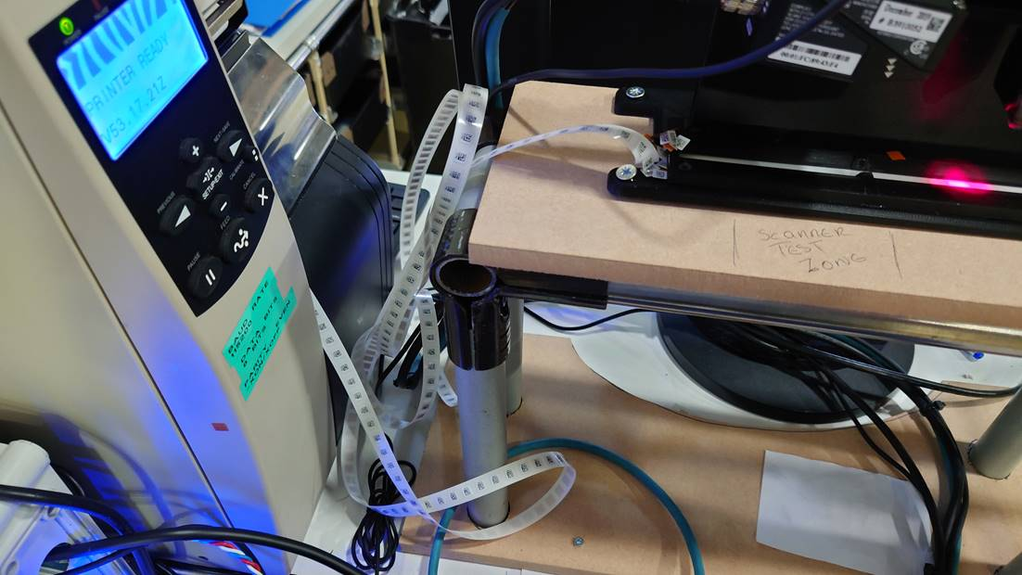



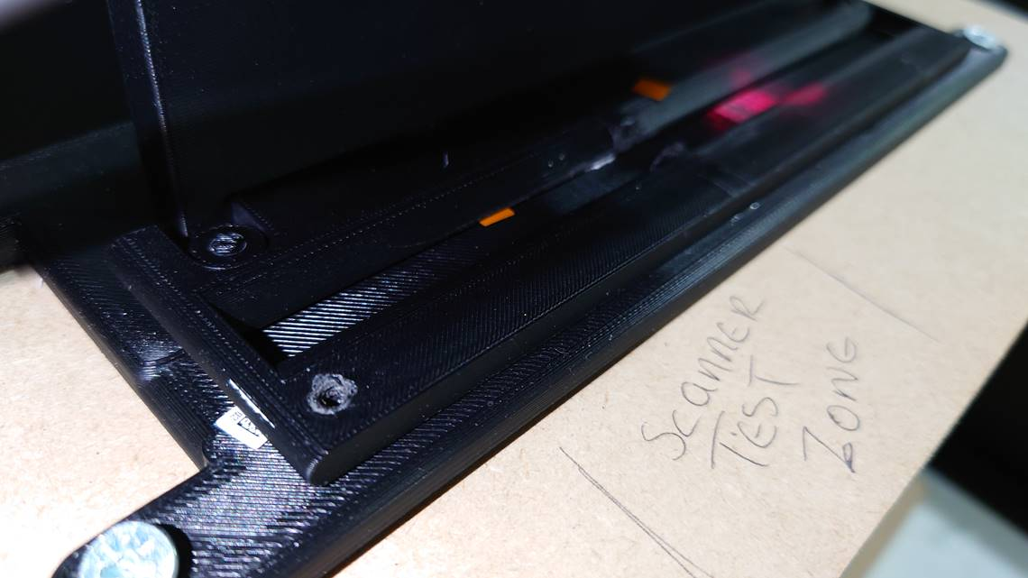

# Fix/s Implement

* A fix was issued at software level. The latest version of the pcb_print software will now check for 10 consecutive reads if a barcode has been read through. If this requirement is not met then the printing process will cease.